**I. Contents:**

II. Objectives

III. Experimental design

IV. Installation materials

V. Personal protective equipment

VI. Installation procedure

VII. Corresponding documentation

VIII. References

**II. Objective:**To measure soil moisture, temperature, and electrical conductivity within each TEMPEST treatment plot (Control, Freshwater, and Seawater) using an array of spatially distributed [TEROS 12 sensors](https://www.metergroup.com/environment/products/teros-12/). This protocol describes the TEROS 12 experimental design and installation and data collection procedures.

**III. Experimental design:** Each TEMPEST treatment plot has been divided into 80, 25 m2 grid cells. By using this grid-style layout and a centrally-focused experimental design, we aim to maximize plot-level data collection on soil moisture, temperature, and electrical conductivity. Meter TEROS 12 sensors will be installed in 36 centrally located grid cells within each plot: 31 locations will have a single sensor at 15 cm below the soil surface and 5 locations will have three sensors installed at 5, 15, and 30 cm below the soil surface (46 sensors/plot).

Each treatment plot contains 3 data logger stations. Each data logger station will service 16 TEROS 12 grid cells, dividing the plot into 3 data logger service areas. Within each logger service area, junction boxes will be used as an intermediate between the TEROS 12 sensor and data loggers. Each junction box will service 4 grid cells. Finally, TEROS 12 sensors within each logger service area will receive a unique “address”: single depth sensors will be denoted with a-m and depth-profile sensors will be recorded as A-J.

Data structure hierarchy:

Plot > Data logger station > Junction box > Grid cell > Address

Plot-specific TEROS 12 sensor locations are provided below:

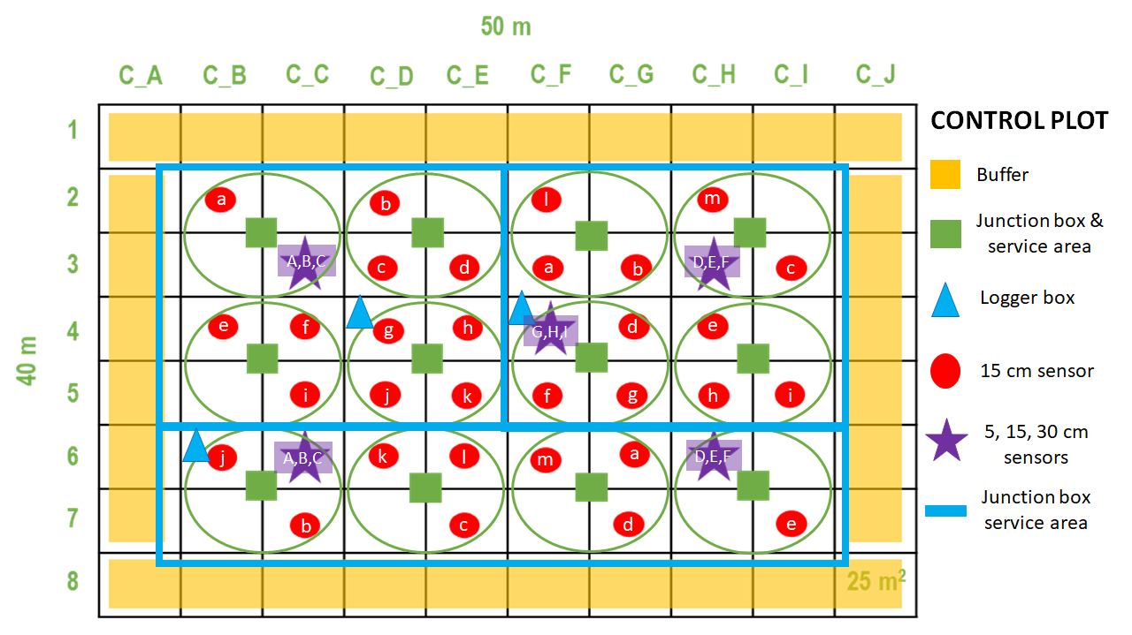

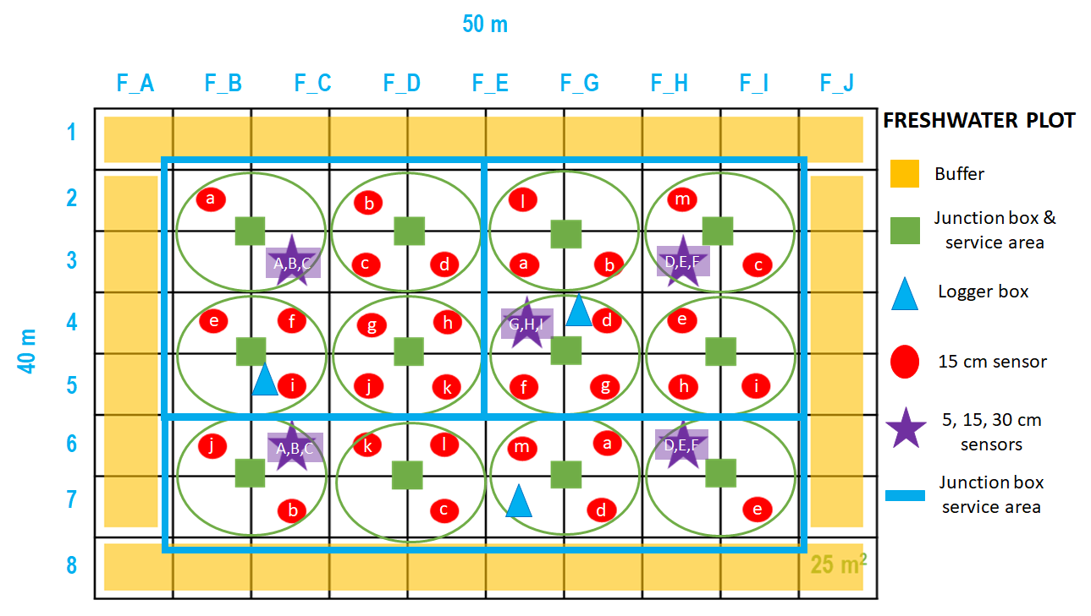

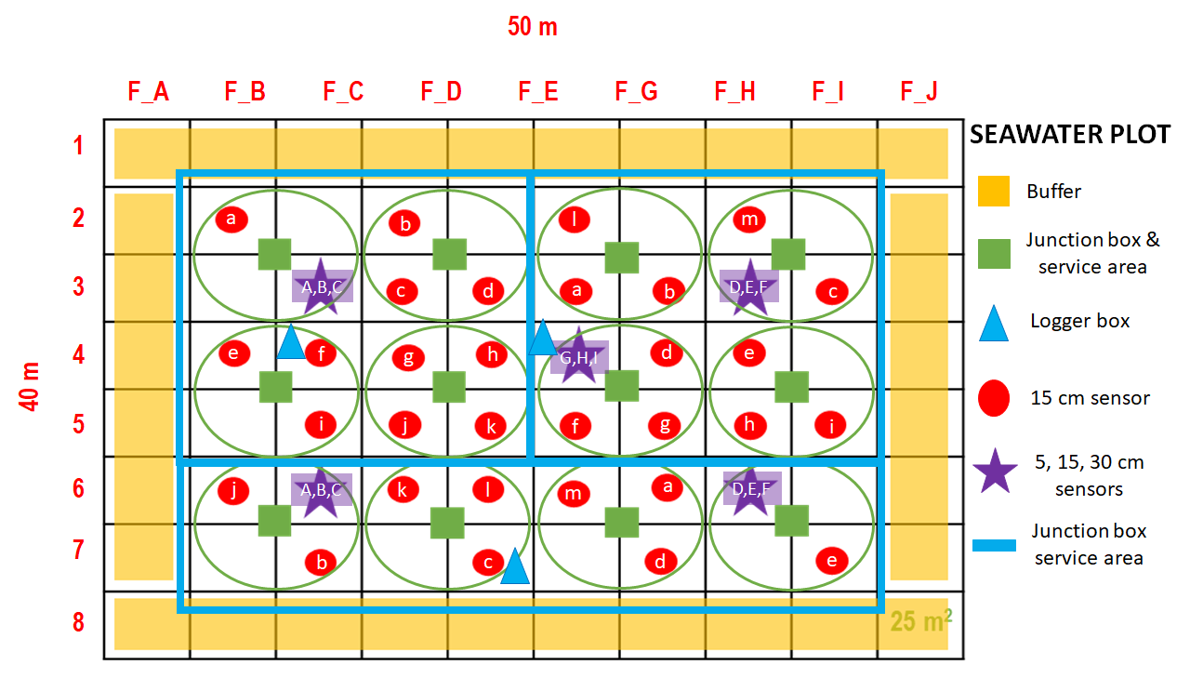

**IV. Installation materials:**

*Stage 1 - junction boxes installation:*

* 36 [junction boxes](https://www.digikey.com/product-detail/en/bud-industries/NBF-32306/NBF-32306-ND/2328233)
* 72 [glands](https://www.ferrulesdirect.com/products/pg1614gy)
* 72 [lock nuts](https://www.ferrulesdirect.com/products/pg16ln-g)
* 72 [½” hose clamps](https://www.grainger.com/product/GRAINGER-APPROVED-1-2-Wide-16P283)
* 36 1’ right-angle aluminum bars

*Stage 2 - TEROS 12 installation:*

* 4” diameter soil auger
* [TEROS 12 sensors](https://www.metergroup.com/environment/products/teros-12/) (prepped for wiring in lab)
* Tarp for soil collection
* Ruler
* Scissors/box cutter
* Hand pruners
* [¼” UV resistant high-temp split loom](https://www.delcity.net/store/1:4%22-UV-Resistant-Split-Loom/p_811413.h_807070)
* [Loom insertion tool](https://www.delcity.net/catalogdetails?item=909900)
* Flagging to mark sensor location (plastic only! No metal)
* [Blue](https://www.digikey.com/product-detail/en/phoenix-contact/3002761/277-15790-ND/7596626), [black](https://www.digikey.com/product-detail/en/phoenix-contact/3002781/277-15807-ND/7596642), and [white](https://www.digikey.com/product-detail/en/phoenix-contact/3002778/277-15804-ND/7596639) distribution blocks

*Stage 3 - Connection to data logger:*

Note: electrical components (ferules, crimpers, wire cutters, etc..), wire, and tools provided by Roy Rich.

**V. Personal protective equipment:**

Close-toed shoes and long pants are required at all times while working at the TEMPEST site. Work gloves are also recommended for this protocol.

**VI. Installation procedure:**

Note: data logger stations were installed prior to the development of this protocol; thus, we do not review their installation procedures.

*Stage 1 - junction box installation:*

1. Drill two 1” diameter holes in the bottom of each junction box
2. Fit each hole with a gland and lock nut
3. Mount junction box to 1’ aluminum bar using hardware included in the box
4. Mount junction boxes to assigned grid locations (shown above) using two hose clamps

*Stage 2 - TEROS 12 installation:*

1. Use 4-in diameter auger to dig a hole approximately 5 cm below the desired sensor depth
2. Install sensor at 15 cm depth, vertical-facing with cable junction facing up, perpendicular to the soil surface (see fig 1)
   1. Note: depth is measured in reference to the middle sensor prong
   2. Note: for depth profiles, stagger sensors around the hole (fig 2) and install at 5, 15, and 30 cm
3. Backfill soil into hole, packing it to similar compact-ness to maintain natural water flow around the sensor
4. Run loom onto sensor cable, leaving a few inches into the ground and up to the junction box
5. Repeat above steps until the plot is complete

**At the end of this stage, all sensors should be installed, backfilled, and in junction boxes.**

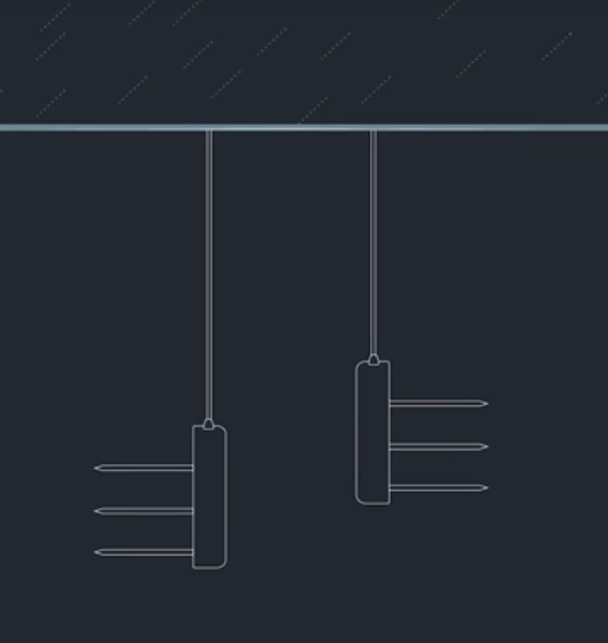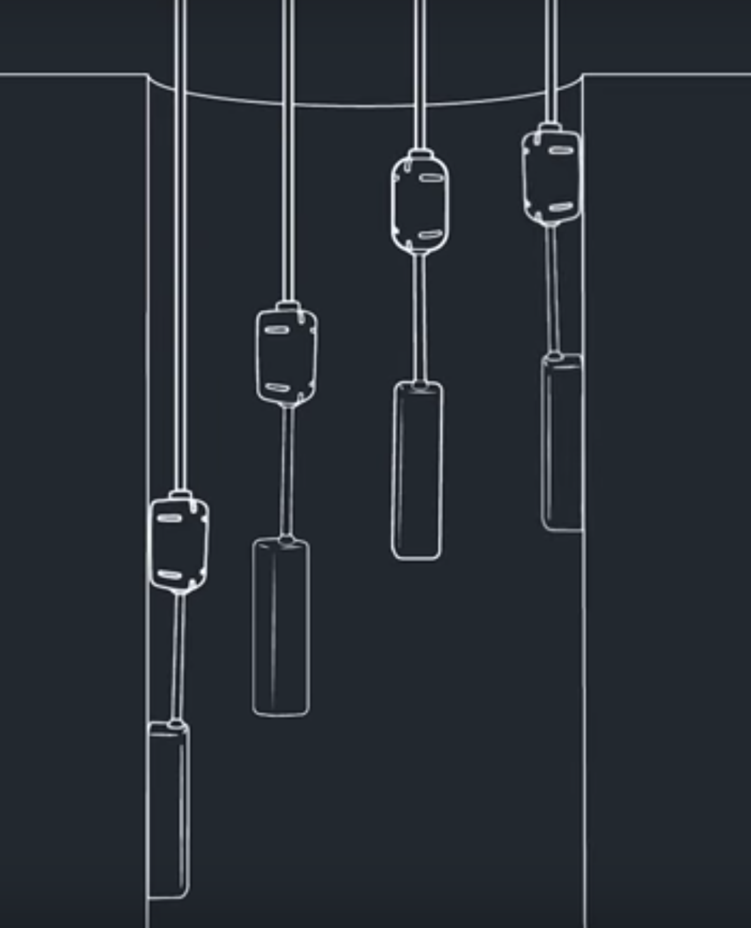

*Stage 3 - connection to data logger:*

1. Connect sensor cable to distribution blocks inside junction box (see fig 3). **Brown** is power = **black** block, **orange** is data = white block, and **bare** is ground = **blue** block.
2. Connect green cable wires to the corresponding distribution blocks inside of the junction box
3. Run the green cable to the nearest grid square pole and follow the grid lines to the designated data logger station (combine cables where possible).
4. Leave enough slack at the data logger to cable tie to the post, do not connect to datalogger.



**VII. Corresponding documentation:**

Unique sensor ID numbers, address, and grid cell locations can be found in the accompanying spreadsheet “TEMPEST_TEROS 12 location and ID”.

**VIII. Reference materials:**

Video: [Best practices: Installing TEROS Soil Moisture Sensors](https://www.youtube.com/watch?v=6WhwDE4D94I)